

**IE322 – Computer Applications in Industrial Engineering I**

**KAU Book Borrowing Application with Location-Based Discount**

|  |  |  |
| --- | --- | --- |
| **Member** | **Name** | **ID#** |
| 1 | Saher Omar Batrfi | 2337157 |
| 2 | Ziad Al-Ghamdi | 2339546 |
| 3 | Ahmed Ayoub | 2237926 |
| 4 | Majed Al-Khuraymi | 2237388 |
| 5 | Abdullah Mahmoud | 2237216 |

**Department:** Industrial Engineering, King Abdulaziz University (KAU)

**Instructor:** Dr. Muhammad Atif Shahzad

**Spring:** 2025

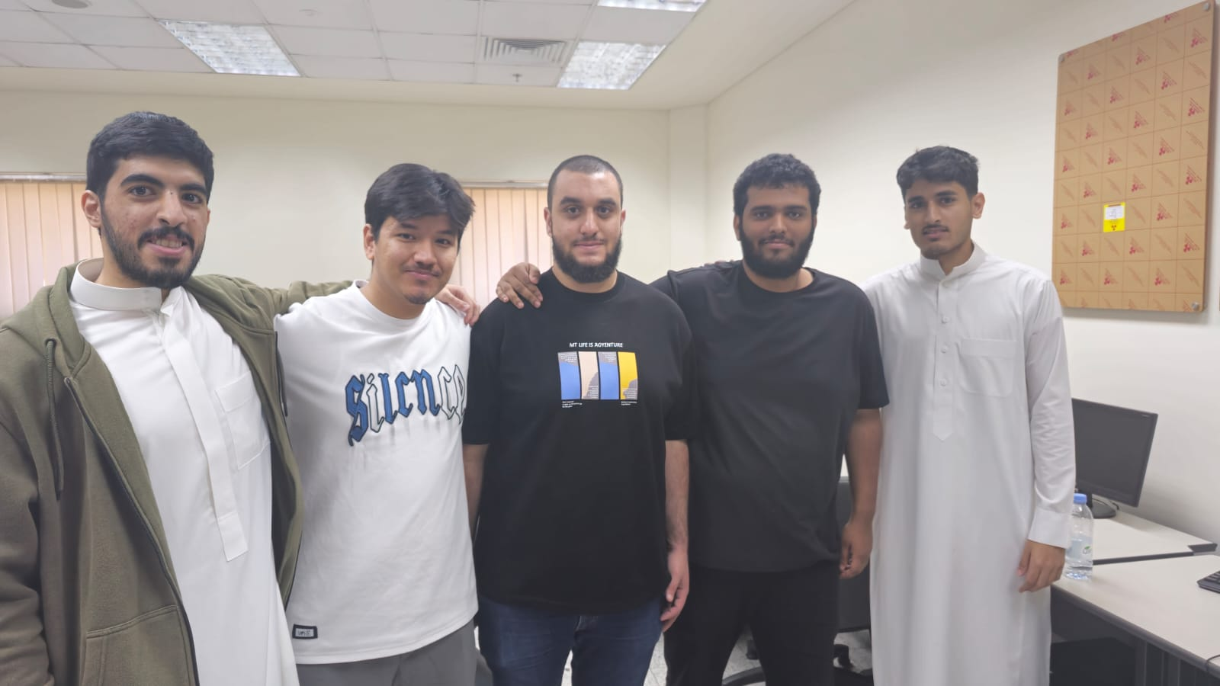Team 13

**Abstract**

This project presents the design and implementation of a location-aware desktop application for borrowing engineering textbooks at King Abdulaziz University (KAU). The primary aim is to create an intelligent borrowing system that provides a 20% discount to users who are physically located within a 6.2-kilometer radius of the KAU campus. The system was developed using C# with Windows Forms and integrates an IP-based geolocation service to determine the user’s position. It utilizes the Haversine formula to calculate the distance between the user’s location and the university’s central coordinates. The application allows users to select textbooks, define quantities, and receive a detailed breakdown of the total cost, both with and without the discount. The solution supports user convenience and encourages physical presence on campus while applying real-world programming, mathematical modeling, and GUI design principles. Test results confirmed accurate discount application based on location, demonstrating the effectiveness and practical value of the system.

## **Acknowledgment**

I would like to express my sincere gratitude to Dr. Muhammad Atif Shahzad for his continuous guidance, feedback, and support throughout the development of this project. His insightful instructions during the IE322 course greatly contributed to both the technical and conceptual success of the application. I also extend my thanks to my fellow classmates and friends for their encouragement, collaboration, and assistance during testing and review. Finally, I am grateful to King Abdulaziz University for providing the tools, resources, and environment necessary to apply engineering knowledge to real-world problems in an innovative and impactful manner.

**Contents**

* Introduction …………………………………………………………...……………..3
* Problem Definition …………………………………………………………………..3
* Objectives …………………………………………………………..……………….4
* System Modeling and Requirements ………………………………………………..4
* Design and Development ……………………………………………………………5
* Code Implementation and Logic ……………………………………………………5
* Testing and Results ………………………………………………………………….5
* Learning Outcomes …………………………………………………………………6
* Future Enhancements ……………………………………………………………….6
* Conclusion ………………………………………………………………………….7

**Introduction**

In every university, textbooks are one of the most important tools that help students learn and succeed in their courses. This is especially true for engineering students, who often study complex subjects that require detailed and reliable reference books. However, many students face a common problem textbooks are expensive, and not all students can afford to buy every book they need. Sometimes, the university library may not have enough copies for everyone, or students may need the book outside of library hours. With the help of technology, we can now solve some of these problems in smarter ways. In this project, we decided to create a desktop application that allows students to borrow engineering textbooks using a simple and easy-to-use software. But we didn’t stop there we wanted to add something more useful and modern. That’s why we included a special feature that checks the student’s location and gives them a discount if they are near the university campus. The main idea is to encourage students to stay on or near campus, while also helping them save money when they borrow textbooks. We use their IP address to find their approximate location, then calculate the distance from the center of King Abdulaziz University (KAU). If they are within 7.2 kilometers of the university, they automatically receive a 20% discount on the total cost. This project combines software development, user interface design, and simple location-based logic to create a practical solution for students. It shows how programming can be used not just to build tools, but to improve daily academic life. The application is a useful and relevant tool for students at KAU, and it can be expanded in the future to support more features, such as login, history, and mobile access.

**Problem Definition**

Many students at King Abdulaziz University face difficulties in acquiring essential engineering textbooks due to high costs or limited library availability. Traditional textbook borrowing systems do not account for a student’s context, such as whether they are present on campus. With limited tools that adapt to the user’s location, there is a lack of intelligent systems that provide tailored access and incentives. This project seeks to fill that gap by introducing a borrowing system that not only allows students to select and borrow textbooks digitally, but also offers discounts based on their physical proximity to the university campus.

**Objectives**

* To design and develop a user-friendly Windows Forms application that enables students to borrow engineering textbooks.
* To implement a smart discount system that grants a 20% reduction in cost for users located within a 7.2 km radius of the KAU campus.
* To integrate geolocation functionality using IP-based services and calculate real distances using the Haversine formula.
* To enhance the user experience by providing clear cost breakdowns before and after discount application.
* To demonstrate practical integration of programming, mathematical modeling, and real-time data usage within an academic context.

# **System Modeling and Requirements**

The system is designed with a clear set of functional requirements that directly address the problem identified during the initial phase. The application must provide a list of standard engineering textbooks used in KAU courses, such as Engineering Economy, Thermodynamics, and Electric Circuits. Users should be able to select multiple books through a simple graphical interface and input the desired quantity for each selection. In addition, the system must include integration with a geolocation service that uses the IP address of the user to detect their current location. If the user is found to be located within the designated KAU zone, the system should automatically apply a discount to the total cost. From a technical standpoint, several constraints were considered during the development to ensure the project remained practical and achievable. The application was required to be built in C# using Windows Forms, ensuring compatibility with desktop systems. Mobile and web platforms were not supported in this version. Location detection is limited to IP-based geolocation services, as GPS integration was beyond the current scope. Furthermore, the logic for discount application is based on comparing the user’s coordinates with a fixed reference point representing the central location of the KAU campus.

# **Design and Development**

The development of the application relied on a structured and modern technology stack. The core programming language was C#, and the development environment used was Microsoft Visual Studio. The interface was created using Windows Forms, a popular .NET-based GUI framework. For detecting the user’s location, the system utilized the ip-api.com service, a reliable and free IP geolocation API. To determine whether the user was inside or outside the KAU campus, the system used the Haversine formula, which was implemented manually to calculate the distance between two sets of coordinates. The application was built with the user in mind, ensuring ease of use and functionality. Key features included a ListBox for selecting books, a TextBox for entering quantities, and another ListBox to represent the user’s cart. A button was added to calculate totals and apply the discount if applicable. Another form, called the SummaryForm, was designed to display the final invoice in a clean format. The coordinates for KAU (21.4933, 39.2458) were used as a reference point, and distances were converted from kilometers to meters to improve precision. When the system detects that the user is within 7200 meters of this point, a 20% discount is applied automatically.

# **Code Implementation and Logic**

The application was divided into three core components. The Form1.cs file serves as the main user interface, enabling users to select books, input quantities, add items to a cart, and trigger the calculation of totals and applicable discounts. The LocationService.cs file is responsible for determining the user’s location through IP-based detection and applying the Haversine formula to determine distance. This result is then compared against a 7200-meter threshold. Finally, the SummaryForm.cs file handles the display of the final invoice, which includes the full breakdown of the cart contents, pricing before and after the discount, and the status of the discount eligibility.

# **Testing and Results**

The application was tested in different scenarios to confirm whether it correctly applied the discount based on location. In the first test, the system was run using an IP address located within the KAU campus via the university's Wi-Fi. The discount was correctly applied, demonstrating successful detection and logic execution. In the second test, a remote IP address was used, representing a user outside of the 7.2 km range. The system correctly withheld the discount, providing the full borrowing cost. These tests confirm that the system functions as expected in real-world conditions. In each case, the system generated a detailed summary that included book names, quantities, unit prices, subtotals, and total prices before and after the discount. It also noted whether the discount was applied. For debugging and verification, the calculated distance in meters was available as part of the backend output.

# **Learning Outcomes**

This project greatly contributed to the student’s technical development by applying real-world programming concepts in a meaningful way. It involved object-oriented programming, external API integration, and the use of mathematical models like the Haversine formula. The student also learned how to build a functional GUI, manage user interactions, and work with multiple forms within a Windows environment. The project also introduced basic network operations through IP-based location services, and emphasized best practices for using GitHub for version control, tracking, and collaboration. These experiences align closely with several Course Learning Outcomes (CLOs), especially those related to system modeling, software development, and problem-solving.

# **Future Enhancements**

Although the project successfully meets its objectives, several improvements could enhance its functionality. First, the system could move from IP-based geolocation to device-level GPS for higher accuracy. This would make the application more suitable for mobile and tablet use. A secure login system could be added to verify whether users are actual KAU students, ensuring that only eligible users receive the discount. The system could also store borrowing records in a local or cloud-based database for future tracking. Additionally, developing a mobile-friendly version of the app using tools like Xamarin or MAUI would increase accessibility. Lastly, connecting the application to a live inventory database would allow it to show which books are available or out of stock, making it more practical for everyday use.

## 

## **Conclusion**

The KAU Book Borrowing Application successfully demonstrates how industrial engineering students can integrate computing, mathematics, and system design principles into a usable solution. By leveraging C# Windows Forms, geolocation, and distance logic, the team developed a desktop solution that simplifies textbook borrowing and incentivizes physical presence within the university. The system not only meets functional requirements but also opens the door for future expansion and innovation. The application is fully testable, lightweight, and suitable for immediate use in academic environments. It provides a solid foundation for further projects involving dynamic pricing, location-awareness, and academic resource management.